* 3.2
  + **Your goal is to navigate a robot through a maze. The robot starts in the center of the maze facing north. You can turn the robot to face North, East, South, or West. You can direct the robot to move forward a certain distance, although it will stop before hitting a wall**
    - **A. Formulate this problem. How large is the state space**
      * Can turn 4 directions(4)
      * Moving forward or not(theoretically infinite) because the distance can be specified
        + Theoretically infinite number of states
    - **B. In navigating a maze, the only place we need to turn is at the intersection of two or more corridors. Reformulate this problem using this observation. How large is the state space now?**
      * Can turn in 4 directions (4)
      * Intersection or no(2)
        + Technically 8 possible state spaces since distance isn’t specified
    - **C. From each point in the maze, we can move in any of the four directions until we reach a turning point, and this is the only action we need to do. Reformulate the problem using these actions. Do we need to keep track of the robots orientation now?**
      * Each turn is a node
        + Number of state spaces varies per node corresponding with the number of possible turns (1-3)
      * Not Necessarily.
        + If the robot keeps a record of its decisions up to it’s current state as well as the record of turns. It should be able to back track without needing to know it’s orientation
    - **D. In our initial description of the problem we already abstracted from the real world, restricting actions and removing details. List three such simplifications made**
      * We restricted movement to the 4 cardinal directions
      * We were only able to move forward
      * The robot stops automatically before hitting a wall
* 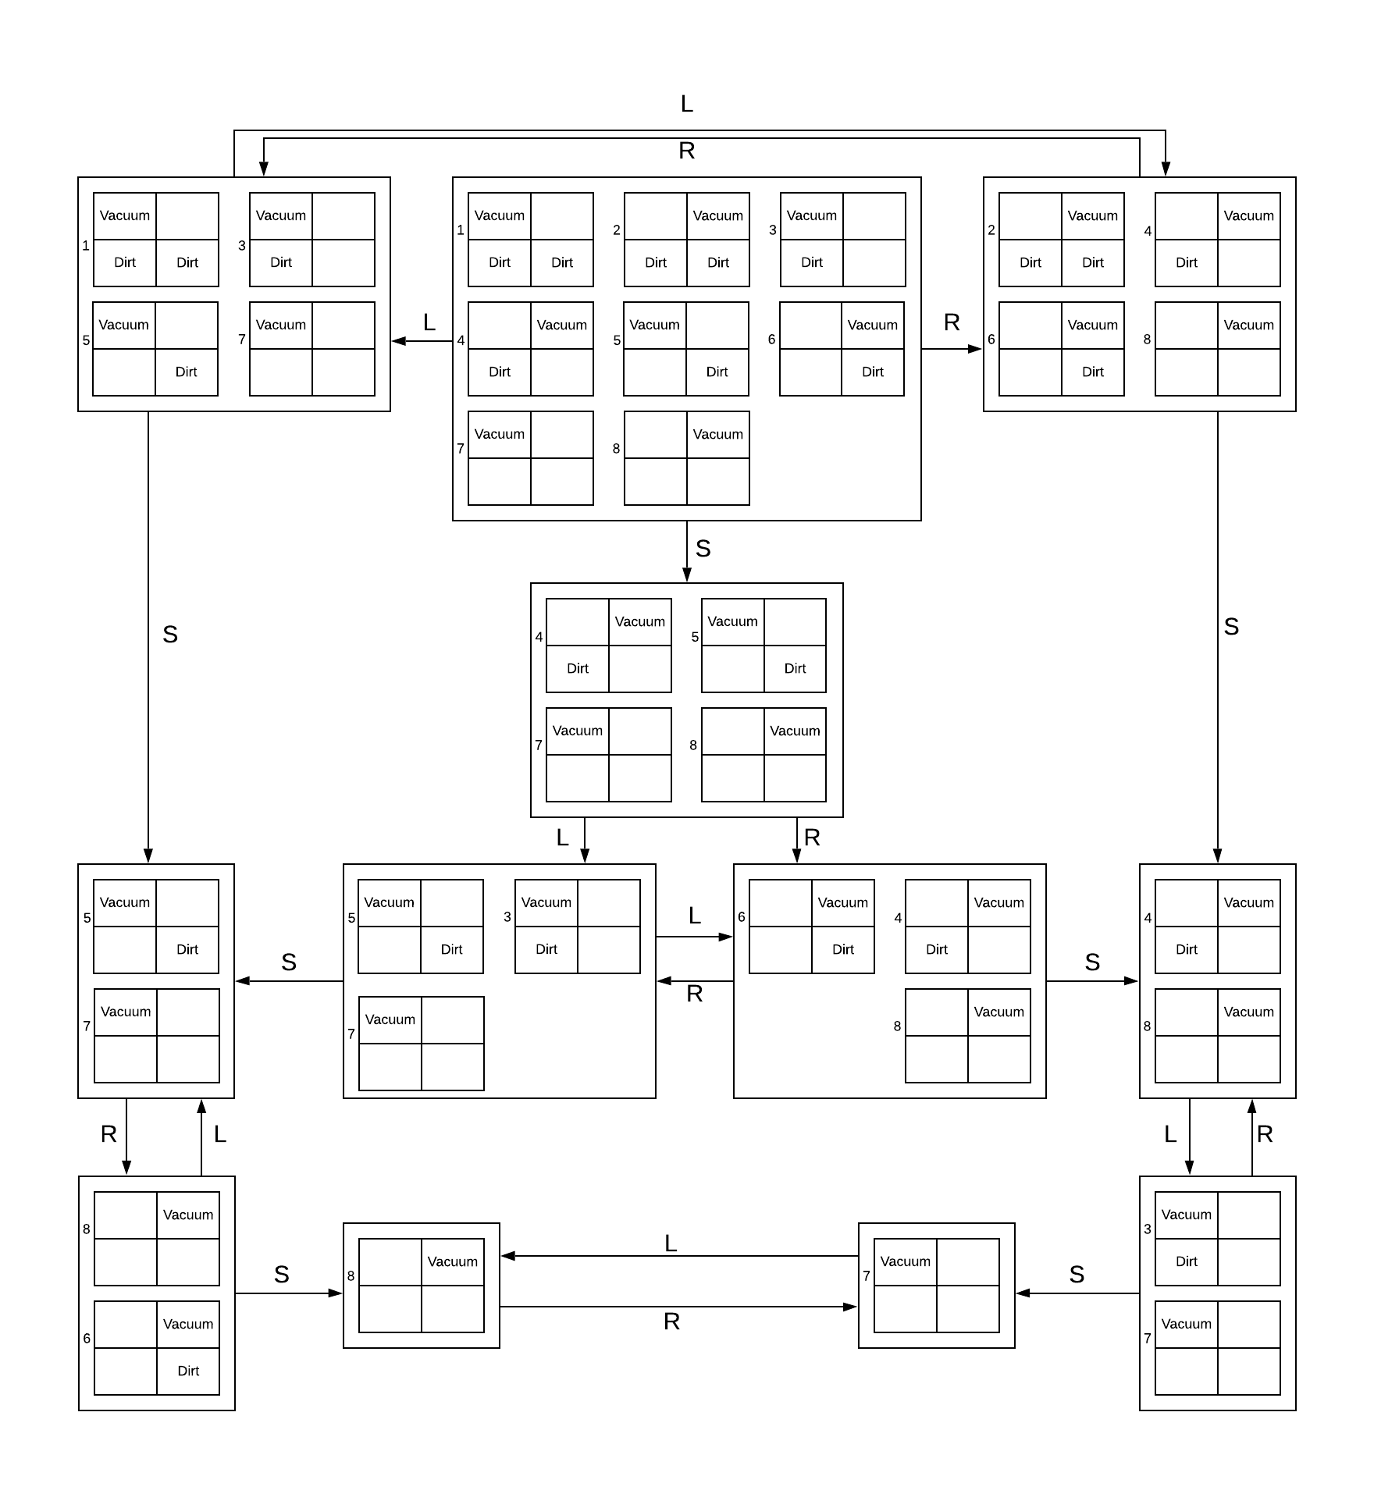Consider the sensorless version of the erratic vacuum world. Draw the belief-state space reachable from the initial belief state{1,2,3,4,5,6,7,8}, and explain why the problem is unsolvable
  + There is no single action or sequence of actions that can take the agent from the initial state to the goal state